**Software Engineering Challenge**

**Requirements**

Describe the challenge or problem, what does the program need to do

Need a cityscape with at least 2 animations

What classes/objects do you think you need?

(Windows is one) Planes

How much time do you think you will you need to complete the project?

About 5 work days

**Research**

What knowledge or skills will you need to build this program

Arrays, graphics

Do you foresee any problems or constraints, describe

I may have problems trying to animate my various items

Have you created a similar programs? Are there similar programs in the book or other resources?

If so, what elements of that project can you bring to this project?

The drunkard walk was sort of similar, I can use that to help.

Do you have the resources you need to create the program?

Yes

Do you need to learn any new knowledge or skill(s) to create the program?

Yes

**Design**

Draw/create a basic graphic you plan to build - attach the drawing

(paint, word, photo shop) not every objet (draw one example although there may be several in the final program) needs to be in the basic graphic

Include a task list--what will you need to do and in what order

1 Create Design

2. Create classes

3. Create windows, cars, and planes

Estimate the amount of time you will need to complete each part the project

I will probably need around an hour to an hour and a half per each moving object

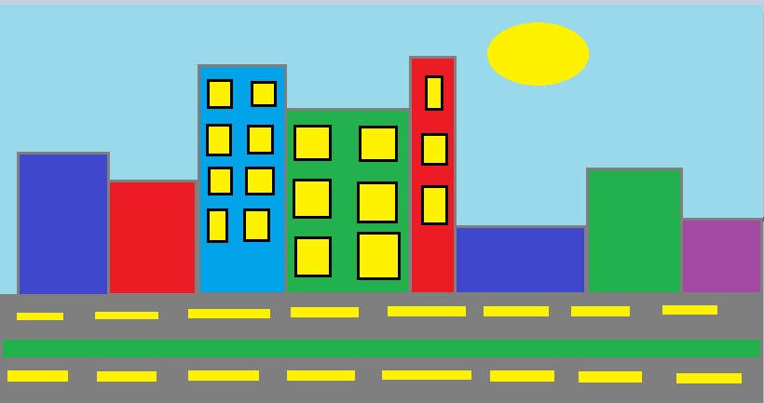

**Construction – included in summary doc**

Document your construction progress with date and progress made (build a chart/table in word or excel), also, include at least three screen shots of your city (beginning, middle, and end)

**Testing/Results/Delivery—summary doc not required to start project**

Preliminary testing

Does your program meet the needs of the initial challenge or problem? How do you know?

Are any changes or modifications needed, why or why not? Document any changes.

Summarize the project - what worked, what didn’t work, note your successes and/or failures.

Looking back, would you have done anything differently, why or why not

Software Summary Document

Daily Progress Report

|  |  |
| --- | --- |
| Date | Description |
| January 16, 2017 | I completed my design and planning document, set up classes |
| Jan 26, 2022 | Add cars |
| Jan 27, 2022 | Finish Sun/moon and cars |